Power Demo

# Overview

This demonstration shows how to measure RDK power use as various peripherals are disabled under user control. Measure current by splitting open a USB cable, cutting the red power line, stripping the insulation off its ends, and inserting an ammeter across the cut wire.

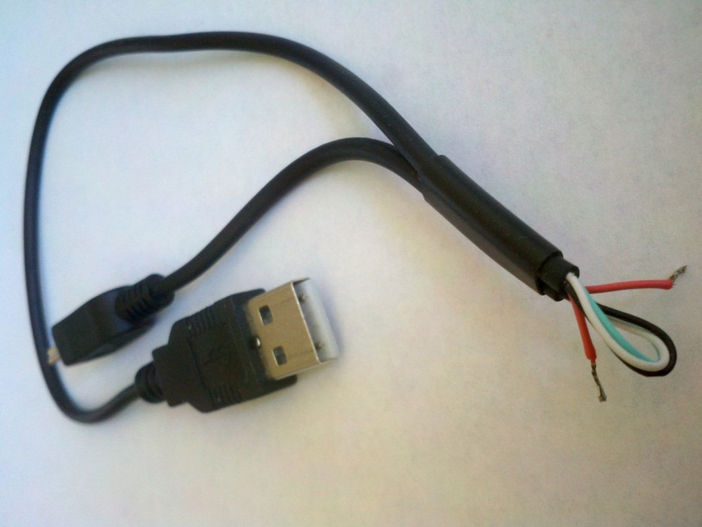

# Comments and Suggestions

* Some multimeters may induce too much of a voltage drop to support USB debugging, leading to repeated failed USB connection attempts. To deal with this, set Switch 5 position 2 to ON to disable debugging and have the RL78/G13 MCU run in stand-alone mode.
* You should observe currents as follows:
  + Start: 79.5 mA
  + LEDS 1-6 off: 63 mA
  + LCD Backlight off: 41.5 mA
  + Speaker amp off: 38.3 mA
  + Mic amp off: 35.4 mA
  + 1 MHz MCU clock: 31.9 mA
  + 32 kHz MCU clock: 31.9 mA
  + All done!
* You can also disable the debug MCU by holding it in reset. The way to do this is to pull pin 2 of J15 (RST-USB) to ground, which is conveniently located at pin 1 of J15. A short wire will do the trick.
  + Debugger reset: 14.5 mA initially, then starts rising.
* Figuring out how to further reduce RDK power is a great discussion topic for class!